Even with all the technology in our world today, we have yet to find a simple procedure to calculate body fat percentage. The current method for accurately calculating the proportion of body fat in an individual involves measuring their weight underwater, which is costly and rarely used. The goal of our project is to make a simple, accurate, and robust model that predicts the body fat percentage of men.
Our body fat prediction model is based on data from a dataset containing 252 males and 17 variables in 1974. The variables in the dataset are ID number, body fat percentage, density, age, weight, height, adiposity(BMI) and the circumference of the individual’s neck, chest, abdomen, hip, thigh, knee, ankle, biceps, forearm and wrist. All of the circumference measurements are in centimeters, but height and weight are not in metric units. The mean value for body fat was 18.94 with a standard deviation of about 7.75.
To begin, we converted the weights to kilograms and heights to centimeters to keep our data consistent within the metric system. Additionally, we removed index 182 from the data, as he indicated a body fat percentage of zero, which is physically impossible. We then used Siri’s Equation with this individual’s measurements to determine if there was a calculation error. Our calculations resulted in a negative body fat percentage, so we chose to remove this individual.
After cleaning the data, we began developing our regression model. Our final model uses abdomen measurement and weight to predict body fat. Since most people have access to a scale and measurement device, using our model would be simple and easy. Our model has an estimated intercept of -42.50181 units in body fat percentage. Our estimated weight coefficient is -0.27146, which means for every additional kilogram of weight, our body fat decreases by .27%, keeping the abdomen circumference constant. Our estimated abdomen coefficient is .90285. This means that if an individual’s abdomen measurement is increased by 1 centimeter, body fat percentage will increase by .9 %, keeping weight constant. For example, a man with a weight of 90 kgs and an abdomen of 100 cm is expected to have a body fat percentage of 23.35% based on our model. His 95% prediction interval is between 15.33% and 31.37% body fat.
In order to develop our model, we first examined each respective independent variable in regards to body fat percentage on a scatter plot. Our initial examinations showed density, adiposity, abdomen, weight, and chest all indicated a clear linear relationship with body fat. We decided not to use adiposity or density as one of our variables since they involve numerous, impractical measurements, taking away from the simplicity of the model we are creating. We then found a simple linear regression model for each of the variables and body fat. We decided to compare different combinations of our variables to see which combination produced the best prediction model. We tested whether a multiple linear regression model gives us a more accurate prediction than a simple linear regression model with only one predictors. The highest R^2 value from the SLR models uses abdomen as a predictor, where 65.59% of the variation in body fat percentage can be accounted for by abdomen circumference. For our MLR model with chest, abdomen and weight, the p-value of the t-statistic for chest is .861. Since this p-value is greater than .05, we chose not to use the chest predictor in our model. In other words, the chest predictor is not useful after accounting for abdomen and weight. Out of the MLR models, we found the highest adjusted R^2 to be about .712 for the model using abdomen and weight as predictors. We found this difference to be great enough to create a MLR model over a SLR model.
Since we decided to use a MLR model, we had to check the assumptions of normality, linearity and homoskedasticity and confirm there are no significant outliers, leverage points or influential points in our model. When analyzing each of these in our model, we discovered one data point that had a high leverage value and Cook’s Distance. Investigating further, we found an abnormally high weight of 164.87 kg. We chose to remove this data point since it is an outlier in X and an influential point due to a high Cook’s Distance and leverage value. We recreated our model excluding this man and found the new adjusted R^2 to be .717, which means 71.7% of the variation in body fat percentage can be accounted for by abdomen and weight. We then reevaluated the assumptions. We checked the linearity and homoskedasticity assumptions using a residual plot, which showed no fanning in or out patterns, so the homoskedasticity assumption is met. The residual plot also does not show any trends and the points are randomly scattered around the x-axis, indicating that the linearity assumption is met (see Figure 1). Then, a QQ plot helped us detect if there are any violations of normality of the error term. The points are all close to the 45 degree line, so normality looks reasonable (see Figure 2). Additionally, we checked for leverage and influential points, using the leverage values and Cook’s Distance. There were no longer any points that highly stood out on both graphs (see Figure 3).
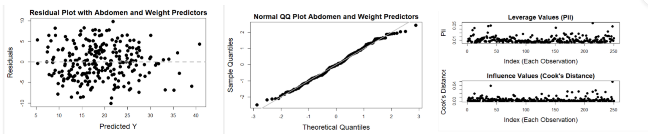
(Figure 1 is on the left, Figure 2 is in the middle, Figure 3 is on the right)
Some strengths of our model is that it is very easy to use due to the fact that only two measurements are required. Additionally, our model satisfies all of the MLR assumptions nearly perfectly and is relatively accurate, as shown with our .717 adjusted R^2 value explained above. A weakness of our model may be the interpretation of our slope coefficients. Our model has a VIF value of 4.16, which may slightly affect our coefficient interpretations, but since our VIF value is still below 5, multicollinearity is not a huge issue. Also, due to the fact that we removed an outlier with a high weight to improve our model, it may be less effective at predicting the body fat percentage for people who have extremely high weights.
All in all, we believe that our regression model is the most effective and practical model possible, given the data. After testing multiple models, we found that this model is the most effective because it has the highest adjusted R^2 value and meets all of the assumptions nearly perfectly. Our simple and robust model allows anyone with a measuring tape and scale to accurately calculate their body fat percentage within a number of minutes.

References
Flynn. “6.3: How Much Fat Is Needed?” Medicine LibreTexts, Libretexts, 16 June 2021,
https://med.libretexts.org/Bookshelves/Health_and_Fitness/Book%3A_Concepts_of_Fit
ess_and_Wellness_(Flynn_et_al.)/06%3A_Body_Composition/6.03%3A_How_Much_Fat_is_Needed.
Musto, Pete. “Average Weight of American Men Increased 7 Kilograms in 20 Years.” VOA,
Average Weight of American Men Increased 7 Kilograms in 20 Years, 29 Aug. 2016,
https://learningenglish.voanews.com/a/average-weight-of-american-men-increases-7-kilograms-in-20-years/3458635.html#:~:text=The%20CDC%20report%20noted%20that,American%20man%20was%2082%20kilograms.
Qassim Ibrahim and Mohammad Ahsan, 2019. Measurement of Visceral Fat, Abdominal
Circumference and Waist-hip Ratio to Predict Health Risk in Males and Females. Pakistan Journal of Biological Sciences, 22:168-173. https://scialert.net/fulltext/?doi=pjbs.2019.168.173#:~:text=The%20abdominal%20circumference%20less%20than,0.70%2D0.85%20for%20female%20participants.

